**Project Goal**

The goal of the project is to develop a Web based booking platform, primarily for barber shops, but in a long run could be adopted by nails saloons or spas. Customers can schedule and cancel their appointment at the chosen barber shop. Barber shops can register and advertise their services, provider schedules for each of their employees. Thanks to that they can shorten the waiting time in their saloons. Additionally, if this goal is finished in a timely manner it will be extended to work on mobile based platform.

**Approach**

The application will have to main users the Customers and the Shops providing the services. Both users will have access to their personal profile and in return will be able to view other profiles in the network. The application will include user log in, register, log out options to have access to the platform. A database to store users’ information. Shops will be able to add employees to their profiles so users can choose from them. And these employees will also be able to add their hours so users have a better understanding of available hours. Both categories of users will be able to edit their profiles to make changes and update information. Users should be able to search for shops they are interested in.

**Progress**

* Front-end design was improved for a better user interface [Implemented by Daniel Bis]
* Date Picker has been added to the project, therefore users can use a friendlier interface to choose dates and times for appointments.

As a USER I can pick a date and time for my appointment [Implemented by Daniel Bis].

* Sign up/Sign in with Google has been implemented.

As a User I can register and log in with Google OAuth [Implemented by Abraham D’mitri Joseph]

* Customers can view the list of all available shops in the system once they log in

As a User I can browse available shops [Implemented by Daniel Bis].

* Service choice has been added to the system, so customers can be more specific on services needed.

As a Shop I can specify services provided

As a User I can choose a service that I’m interested in [Implemented by Daniel Bis].

* Customers can also view previous and upcoming appointments all in their personal profile.

As a User I can browse upcoming and past appointments [Implemented by Daniel Bis].

* Shops can now book appointments for walk in customers with a click of a button. A walk-in option has been implemented.

As a Shop I can add a walk-in customer to the calendar [Implemented by Daniel Bis].

* Shops can browse all of the appointments for the day in the form of a table.

As a Shop I can browse appointments scheduled for today in my dashboard.

[Implemented by: front-end: Christian Pileggi, back-end: Daniel Bis].

**Future work**

* Shops need to be able to book appointment for customers apart from walk ins
* All users should be able to edit their profiles.
* Shops services and times should be arranged chronologically
* Shop schedule table should be interactive
* As a shop add appointments
* Redirections after login
* Confirmation view after creating an appointment
* As a user cancel appointment
* As a shop upload an image
* As a shop add “about”
* As an employee upload a profile picture
* As a user check next available time slot for a shop
* Finish front end design
* Test and debug
* Adding calendar widget for shop to add schedules

**Contribution:**

Mod_auth (authentication module and database models definitions): Daniel Bis

Signup functions together with Christian Pileggi (Pair Programming)

mod_provider (scheduling working hours by managers): Daniel Bis

__init__ and run files: Daniel Bis

HTML Templates: Daniel Bis

test.py : Abraham D’mitri Joseph and Daniel Bis (pair programming)

Heroku deployment: Daniel Bis

Readme: Daniel Bis

Wiki: Ajayi Oluwatobi

Report: Ajayi Oluwatobi, Daniel Bis

**### MILESTONE 4** SPRINT BACKLOG

AS A/AN:USER I WANT TO:Be able to schedule appointments easily with a calendar format SO THAT: I can see all the available dates on in one page PRIORITY HIGH STATUS:DONE (MARCH 14 2018)

* AS A/AN:SHOP I WANT TO: See workload for the day SO THAT: I can plan accordingly PRIORITY HIGH STATUS:(MARCH 18 2018)

* AS A/AN:USER I WANT TO: View profile of all shops available SO THAT: I can make a better decision on my service provider PRIORITY HIGH STATUS:(MARCH 14 2018)

* AS A/AN:USER I WANT TO: Be able to choose a particular employee in a shop SO THAT: I can make sure it's the service provider I prefer PRIORITY HIGH STATUS:(MARCH 14 2018)

* AS A/AN:USER I WANT TO: Be able to choose a particular service from my preferred employee SO THAT: I can make sure it's the service I want PRIORITY HIGH STATUS:(MARCH 14 2018)

* AS A/AN:USER I WANT TO: Be able to choose a time, book it and get a confirmation SO THAT: I can get my service PRIORITY HIGH STATUS:(MARCH 18 2018)

* AS A/AN:USER I WANT TO: Be able to see my upcoming appointments on my profile SO THAT: I can plan accordingly PRIORITY HIGH STATUS:(MARCH 18 2018)

* AS A/AN:USER I WANT TO: Be able to see my past appointments SO THAT: I can keep track of previous appointments PRIORITY HIGH STATUS:(MARCH 18 2018)

* AS A/AN:USER I WANT TO: Be able to log in with Facebook / Google SO THAT: I can sign up/ sign in easily PRIORITY HIGH STATUS:(MARCH 18 2018)

* AS A/AN:SHOP I WANT TO: Be able to add new services to the catalog SO THAT: My customers have more options to choose from PRIORITY HIGH STATUS:(MARCH 18 2018)

**Git Log:**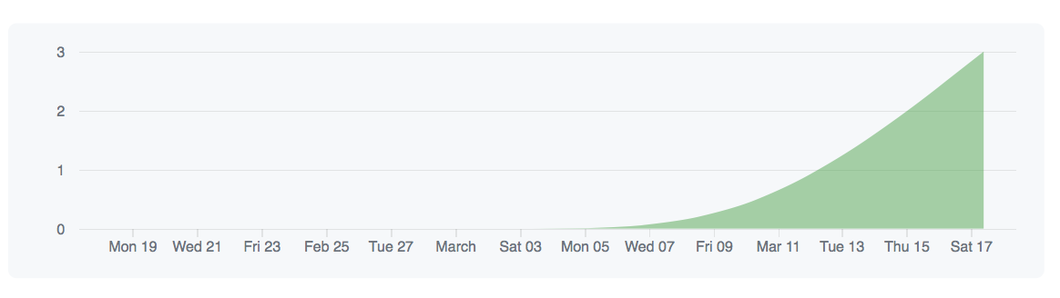

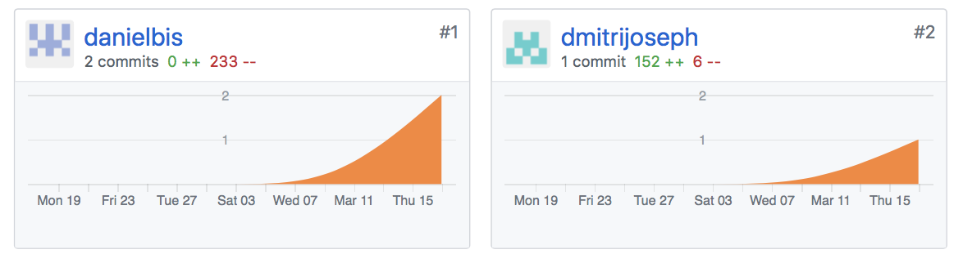

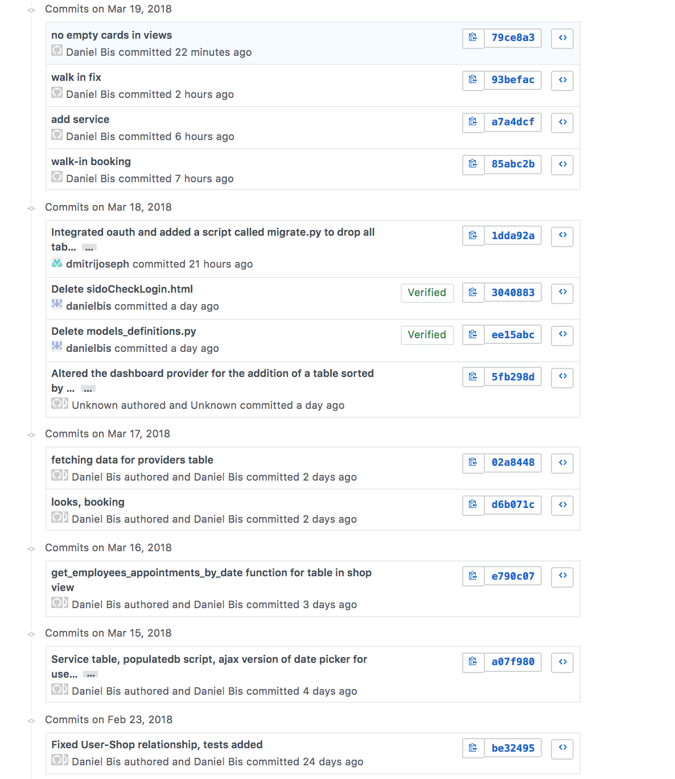

**Heroku Log:**